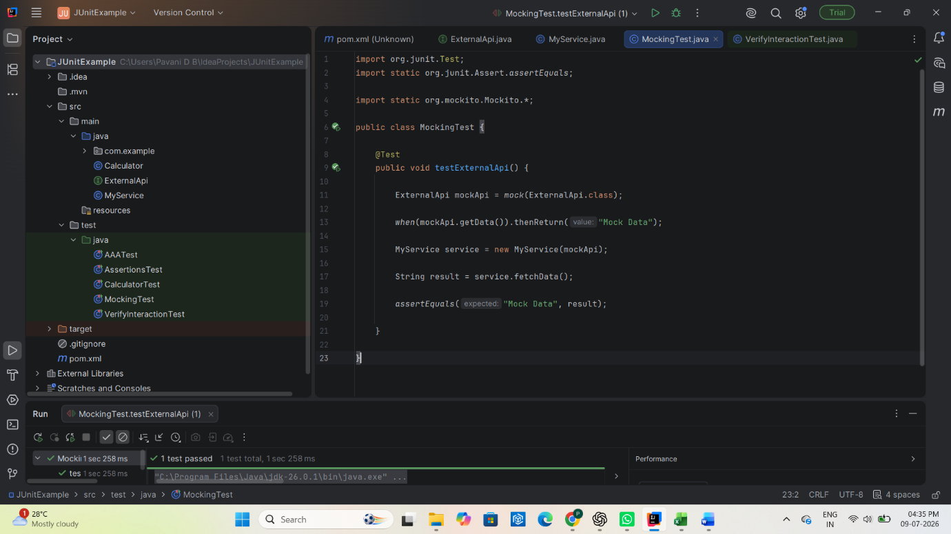
Exercise 1: Mocking and Stubbing
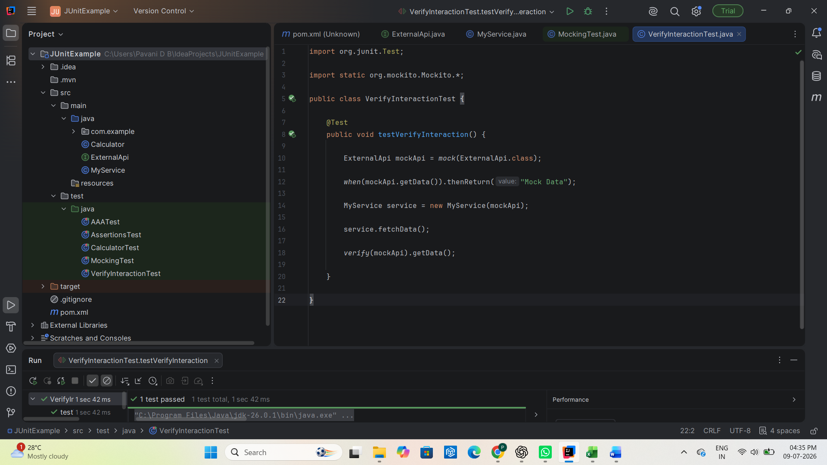
Exercise 2: Verifying Interactions

